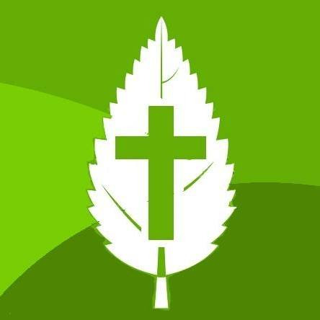
WHYTELEAFE FREE CHURCH
Statement of Faith

We believe in one God eternally existing in three Persons - Father, Son, and Holy Spirit
We believe that Jesus Christ was conceived by the Holy Spirit, born of the virgin Mary, that He is very God and very man; and that all His teachings and utterances are true.
We believe that when the Lord Jesus Christ was crucified, He offered Himself as the representative and substitutionary sacrifice for the sin of the whole world, and that all who repent and believe in Him are justified on the grounds of His shed blood, and therefore constitute His church.
We believe that the crucified body of our Lord was raised from the dead according to the Scriptures, and that He ascended into Heaven, and sits at the right hand of God as our High Priest and Advocate
We believe in the second coming of the Lord Jesus Christ, and that His return to the earth will be visible and personal in the manner which He went,
We believe in the Holy Spirit, the Lord and Giver of Life, who dwells in each believer, proceeds from the Father and the Son inspiring both the Old and New Testament scriptures. These are historically trustworthy and their teaching and authority final.
We believe that man was created in the image of God; that he has sinned and thereby incurred, physical and spiritual death which is separation from God. All human beings are consequently born with a sinful nature and are therefore sinners in thought, word, and deed. We believe in the necessity of regeneration by the Holy Spirit, in order that people may enter the Kingdom of God, and that the evidence of this new life should be manifested in the daily walk.
We believe in the eternal punishment of those who have ignored or rejected the offer of salvation through Jesus, the resurrection of the just and the unjust and the eternal blessedness of the redeemed in Christ

